**1. Captch to be implemented.**

**2. Version control to be implemented.**

**3. Change password page is not working. refer link**

[**http://localhost/GridLogik.Viewer/ChangePassword/Index**](http://localhost/GridLogik.Viewer/ChangePassword/Index)

**4. Remove rolid column from mstrole. if we keep role description blank it show as "null" value.**

**drop table and re-create with script in file**

**5. Show login name on**

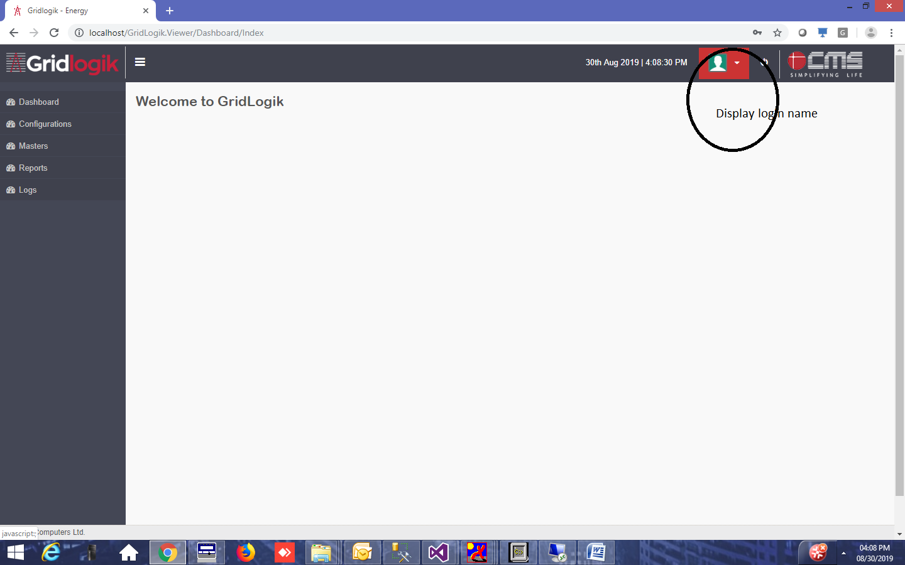

**6. Meter Model : Module name should be unique, apply validation on it.**

[**http://localhost/GridLogik.Viewer/MeterModel/Index**](http://localhost/GridLogik.Viewer/MeterModel/Index)

**7. meter type :- Meter type should be unique.**

[**http://localhost/GridLogik.Viewer/MeterType/Index**](http://localhost/GridLogik.Viewer/MeterType/Index)

**8. Module :**

**Individual Name and Position should be unique. Position should be int only. Datatable is to be binding.**

[**http://localhost/GridLogik.Viewer/Module/Index**](http://localhost/GridLogik.Viewer/Module/Index)

**9. Report manually**

[**http://localhost/GridLogik.Viewer/ReportManually/Create**](http://localhost/GridLogik.Viewer/ReportManually/Create)

**10. check all pages where menu access code is commented. pages should have data table attached.**

**11. Menu page. remove {mnuid}**

12. History data as it is.

13. record is not getting created and downloaded option is not showing alert .

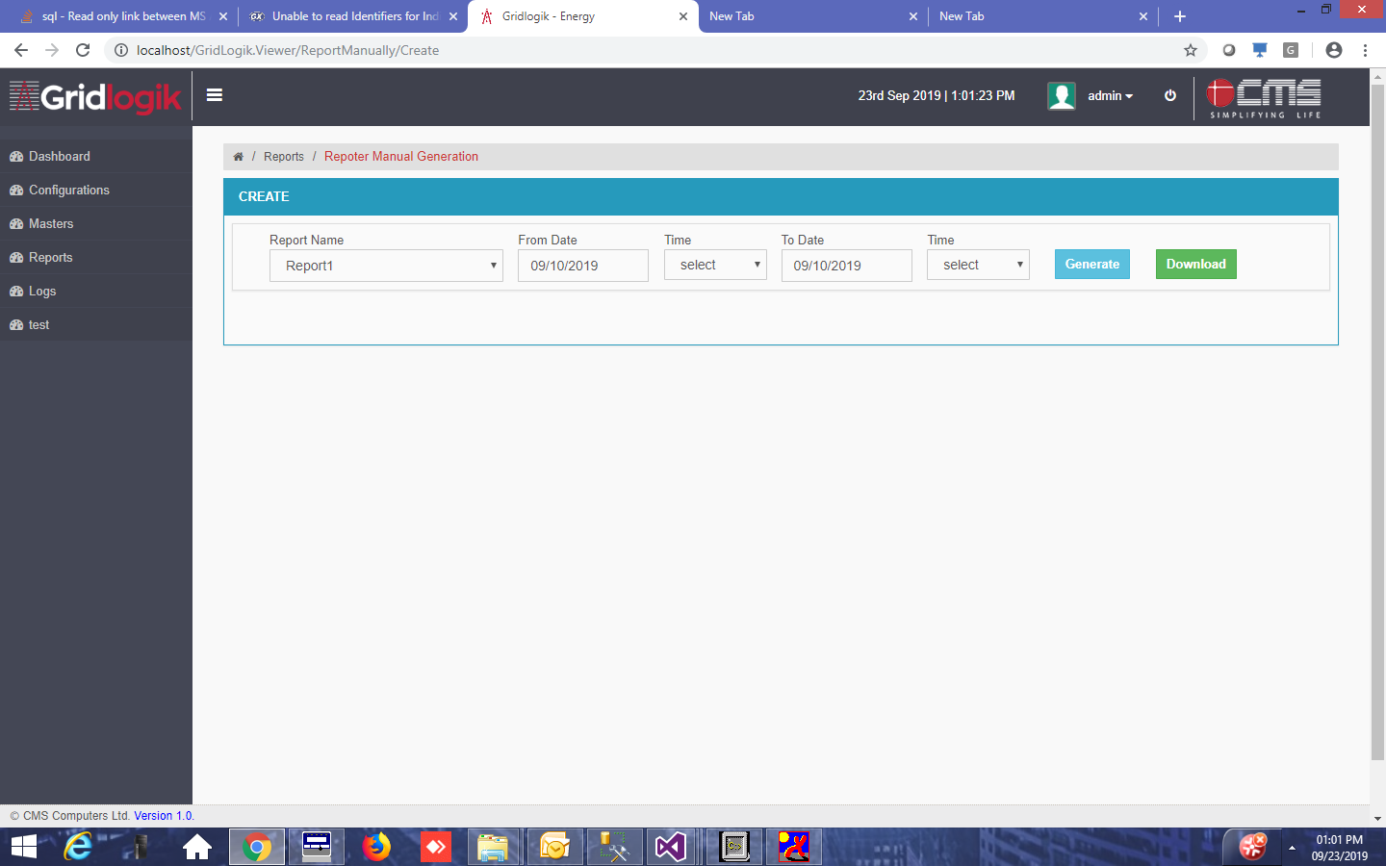

14. meter status page design is not upto update.

